भारत मौसम विज्ञान विभाग |  | India Meteorological Department
Saturday 02nd May 2026 (12th Vaisakha 1948 Saka)
Summary of observations recorded at 0830 hours IST: The western disturbance as a trough in middle tropospheric westerlies ran roughly along Long. 60°E to the north of Lat. 32°N. The upper air cyclonic circulation over north Punjab & neighbourhood lay over north Haryana & neighbourhood at 0530 hrs IST of today. It persisted over the same region at 1.5 km above m. s. l. The upper air cyclonic circulation over Gangetic West Bengal & adjoining Bangladesh lay over north Bangladesh & adjoining Gangetic West Bengal between 1.5 & 3.1 km above m. s. l. with a trough aloft extending between 4.5 & 9.4 km above m. s. l. ran roughly along Long. 87°E to the north of Lat. 20°N. An upper air cyclonic circulation lay over west Rajasthan & neighbourhood at 0.9 km above m. s. l. A north-south trough ran from above the cyclonic circulation over west Rajasthan to Comorin area across East Rajasthan, Madhya Pradesh, Vidarbha, Telangana, Rayalaseema and interior Tamil Nadu at 0.9 km above m. s. l. An east-west trough ran from northeast Madhya Pradesh to Manipur across Chhattisgarh, Jharkhand, West Bengal, Bangladesh and south Assam at 0.9 km above m. s. l. The upper air cyclonic circulation over southeast Bangladesh and neighbourhood became less marked. at 0530 hrs IST of today. However, the trough aloft with its axis at 7.6 km above m. s. l. roughly along Long. 89°E to the north of Lat. 20°N persisted at 0530 hrs IST of today. It became less marked. The western disturbance as a cyclonic circulation over Kashmir & neighbourhood moved away. The trough / wind discontinuity from South Odisha to Gulf of Mannar across Telangana, Andhra Pradesh and Tamil Nadu became less marked. An upper air cyclonic circulation lay over central Pakistan & adjoining Rajasthan between 1.5 & 3.1 km above m. s. l. at 1730 hrs IST of yesterday, the 01st May, 2026. It became less marked at 0530 hrs IST of today. An upper air cyclonic circulation lay over north Odisha & adjoining Gangetic West Bengal at 0.9 km above m. s. l. at 1730 hrs IST of yesterday, the 01st May, 2026. It became less marked at 0530 hrs IST of today.

Maximum Temperature Departures (as on 01-05-2026): markedly above normal (> 5.1°C) at few places over Coastal Andhra Pradesh & Yanam; at isolated places over East Rajasthan. appreciably above normal (3.1°C to 5.0°C) at many places over East Madhya Pradesh; at few places over West Uttar Pradesh and Tamil Nadu, Puducherry & Karaikal. above normal (1.6°C to 3.0°C) at most places over Himachal Pradesh, West Rajasthan and West Madhya Pradesh; at few places over Rayalaseema; at isolated places over Kerala & Mahe. near normal (-1.5°C to 1.5°C) at most places over Konkan & Goa, North Interior Karnataka and South Interior Karnataka. The highest maximum temperature of 44.6°C was reported at Barmer (Rajasthan).

Squall has been recorded over Gopalpur (Odisha) with maximum recorded wind speed of 92 kmph.

Thunderstorm accompanied with Squally/Gusty winds with speed reaching 50-70 kmph prevailed at isolated places over Madhya Pradesh, Himachal Pradesh, Gujarat State, Jharkhand, Assam, Gangetic West Bengal, Odisha; with speed reaching 30-50 kmph prevailed at isolated places over Jammu-Kashmir, Uttarakhand, Chhattisgarh, Tripura, Marathawada, Konkan, Arunachal Pradesh, East Rajasthan and Madhya Maharashtra.

Hailstorm reported over Jammu-Kashmir, Uttarakhand, South Interior Karnataka and Coastal Andhra Pradesh.

Duststorm reported over East Rajasthan.

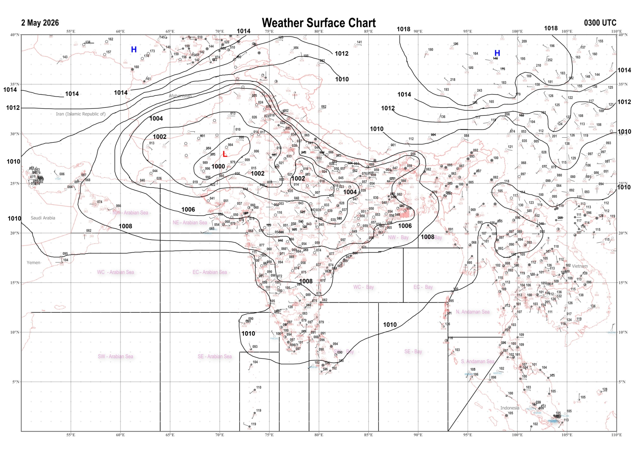 | 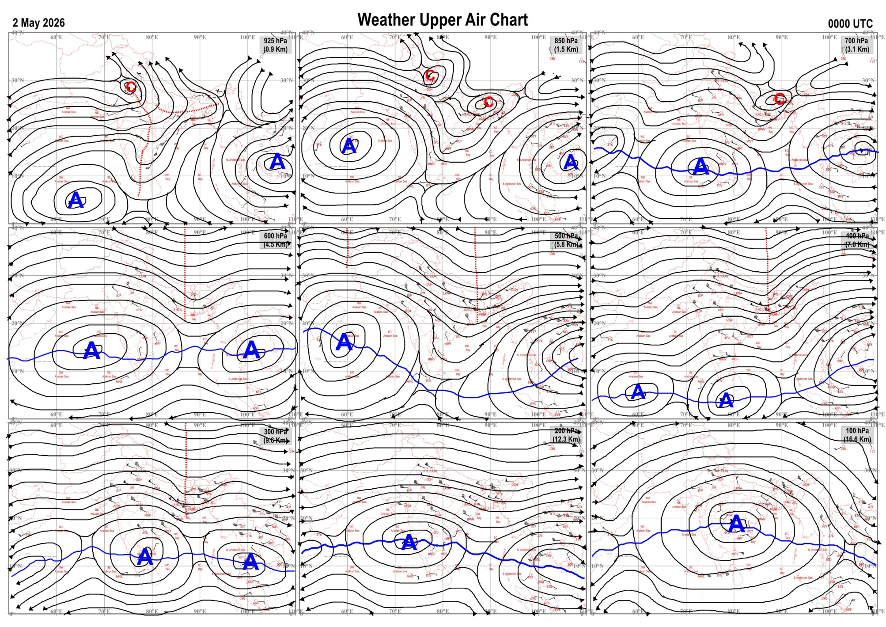
Fig.1. Analysed surface chart based on 03z observation | Fig.2. Analysed upper air chart based on 00z observation
V. K. Shripad
Scientific Officer ‘I’
CR & S Office, Pune  Issued at 1245 hrs. IST |  | Weather Forecasting Division  CR&S, Pune

Indian regions | Realised rainfall (chief amount in cm during past 24 hrs):
East | most places: Sub-Himalayan West Bengal & Sikkim+++  many places: Arunachal Pradesh, Assam & Meghalaya+ and Nagaland-Manipur-Mizoram-Tripura  a few places: Gangetic West Bengal and Bihar+  isolated places: Odisha+ and Jharkhand  Ghish 16.1, Sevoke 14.6, Pranpur 11.4, Kasba 11.2, B p ghat 8.6, Chakapad 7.7, Tikabali 7.2, Purnea 7.0, Balurghat 6.8, Tamenglong 6.0, Majbat 5.3, Chouldhuwaghat ARG 4.9, Jangipur 4.6, Tuting & Manjhari 4.1 each, Khonsa 3.9, Lembuchhera 3.5, Godda 3.4, Nalhati 2.9, Koraput & Jamshedpur 2.4 each, Kailashahar AP 2.0, Berhampore 0.5, Bomdila 0.4.
North | isolated places: east Uttar Pradesh, Uttarakhand, Himachal Pradesh, Jammu-Kashmir and Ladakh and Rajasthan  dry weather: west Uttar Pradesh, Haryana and Punjab  Jakholi 3.4, Shalimar agro 3.3, Nagaur tehsil SR 2.2, Sarahan 1.9, Rudraprayag 1.5, Jayal SR 1.4, Lolab 1.1, Hata, Sawar SR & Lachmangarh 1.0 each, Uttar kashi 0.8, Deoria & Degana 0.6 each, Ajmer 0.5, Kukernag 0.4, Gorakhpur 0.3, Sangla 0.2.
Central | isolated places: Madhya Pradesh and Chhattisgarh◆  dry weather: Vidarbha  Panagar 0.9, Sleemanabad 0.8, Umaria-aws 0.6, Sheopur-aws 0.3, Baramkela 0.2, Hasaud 0.1.
Peninsula | a few places: coastal Andhra Pradesh+  isolated places: Telangana◆, Rayalaseema, Tamil Nadu, south interior Karnataka and Kerala  dry weather: Gujarat State, Konkan & Goa, Madhya Maharashtra, Marathwada and coastal and north interior Karnataka  Gantyada 8.3, Upasi tea research AWS 5.7, Srungavarapukota 5.5, Valparai PTO & Valparai pap 5.3 each, Mysuru PTO 4.0, Nagamangala 2.8, Kalingapatnam 2.7, Anayirankal dam AWS 2.5, Myladumpara ARG 2.4, Bengaluru city 1.3, Kuppam 0.9, Bhainsa (ARG) & Kozhikode 0.1 each.
Islands | a few places: Andaman & Nicobar  dry weather: Lakshadweep  Long island 2.3, Maya bandar 1.7.
Table-2 Forecast / warnings (distribution of rain / thundershowers) for 7 days (valid from time of origin upto 0830 hrsIST of next day)
Sr N. |  | Sub-division Name | Day 1 | Day 2 | Day 3 | Day 4 | Day 5 | Day 6 | Day 7 | Sr. No. | Sub-division Name | Day 1 | Day 2 | Day 3 | Day 4 | Day 5 | Day 6 | Day 7
 |  |  | 02 May | 03 May | 04 May | 05 May | 06 May | 07 May | 08 May |  |  | 02 May | 03 May | 04 May | 05 May | 06 May | 07 May | 08 May
 | 1 | Andaman Nicobar Islands | I | I | I | I | I | S | S | 19 | west Madhya Pradesh | I  | I  | I  | I  | I  | I | I
 | 2 | Arunachal Pradesh | W +  | W +  | F +  | S  | S  | F | F | 20 | east Madhya Pradesh | I  | I  | I  | I  | I  | I | I
 | 3 | Assam-Meghalaya | W ++  | W + | F +  | S  | F  | F | S | 21 | Gujarat region | D | D | D | D | D | D | D
 | 4 | Nagaland-Manipur-Mizoram-Tripura | W ++  | W + | F +  | F  | S  | S | I | 22 | Saurashtra and Kutch | D | D | D | D | D | D | D
 | 5 | Sub Him West Bengal/Sikkim | W ++  | F +  | F +  | W  | F | S | S | 23 | Konkan and Goa | D | D | D | D | D | D | D
 | 6 | Gangetic West Bengal | S  | S  | W  | W  | F | S | S | 24 | Madhya Maharashtra | D | D | D | D | D | D | D
 | 7 | Odisha | I  | I  | S  | S  | I  | I  | I  | 25 | Marathwada | D | D | D | I | I | I | I
 | 8 | Jharkhand | I  | I  | S | S  | S  | S  | S | 26 | Vidarbha | D | D  | I  | I  | I  | I | I
 | 9 | Bihar | I  | I  | F+ | I  | S  | I  | I  | 27 | Chhattisgarh | I  | I  | S  | S  | I  | I | I
 | 10 | east Uttar Pradesh | I | I | S  | S  | S | S  | I | 28 | Coastal Andhra Pradesh and Yanam | I  + | I  + | S + | S+ + | S +  | S | I
 | 11 | west Uttar Pradesh | D | I  | S  | S  | S  | I | I | 29 | Telangana | I  | I  | S  | S +  | S +  | S | S
 | 12 | Uttarakhand | I  | F  | F | F | S  | S  | S | 30 | Rayalaseema | I  | I  | I  | I  | I  | I | I
 | 13 | Haryana,Chandigarh and Delhi | I  | I  | F | S | I | I | I | 31 | Tamil Nadu, Puducherry and Karaikal | S+ + | I +  + | S++ | S +  | S +  | S + | F +
 | 14 | Punjab | I | I  | F | S | I  | I | I | 32 | Coastal Karnataka | I  + | I | I | I | I | I | I
 | 15 | Himachal Pradesh | I | F  | F  | F  | S | S | I | 33 | North interior Karnataka | I  | I | I | I | I | I | I
 | 16 | Jammu-Kashmir and Ladakh | S  | W | F  | F  | S  | I | I | 34 | South interior Karnataka | I  | I  | I +  | S +  | I +  | I + | I +
 | 17 | west Rajasthan | I  | I  | I  | I  | I  | I  | I  | 35 | Kerala and Mahe | F +  | S +  | S +  | F +  | F +  | F + | F +
 | 18 | east Rajasthan | I  | I  | I  | I  | I | I | I | 36 | Lakshadweep | S  | S | S | S | S | S | S
Legends: D = Dry I =isolated S = Scattered F = Fairly widespread W = Widespread #= heavy to very heavy rain at a few places with extremely heavy rain at isolated places+++= heavy rain at a few places with very heavy rain at isoIated places++= heavy to very heavy rainfall @=isolated exceptionally heavy rainfall+ = heavy rain ●/*= rain or snow ♦ = very light rain ≡=fog = thunderstorm with lightning =Squall / Gusty / gale / strong wind -=cold wave/cold day + = heat wave/warm night/hot and humid weather =Duststorm =ground frost = Hail.

Fig. 4: Districtwise warnings for five days for Maharashtra State
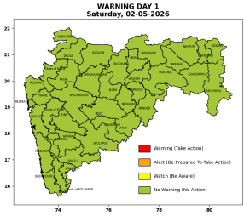 | 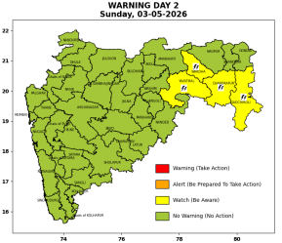 | 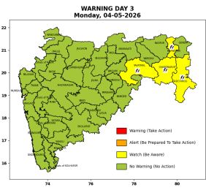 | 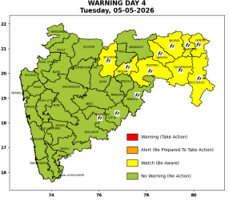 | 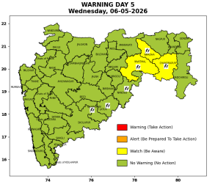

Pune, Lohegaon and Pashan observations at 0830 hrs. IST of Today
 | Temperature (°C) |  |  |  |  | Humidity (%) |  |  |  | Rainfall (mm)
 | Max.  past  24 hrs | Dep.  from  normal | Min.  past  24 hrs. | Dep.  from  normal | Dry  Bulb | At 0830 hrs. IST | Dep.  From  normal | At 1730  hrs. IST of y’day | Dep.  from  normal | Past  24 hrs. | Since  1st March | Dep.  from  normal
PNE | 36.7 | -1.8 | 20.2 | -1.4 | 27.8 | 51 | 1 | 36 | 8 | 0.0 | 92.8 | 77.3
PSN | - | - | - | - | - | - | - | - | - | - | - | -
LHG | 39.3 | 1.3 | 23.3 | 2.3 | 29.9 | 40 | -13 | 19 | -8 | 0.0 | 91.4 | 73.9

 |  |  |  |  |  |  | Local (Pune and neighbourhood) forecast
Max./Min. Temperature (°C) |  |  |  |  |  |  |  |  | Weather
Date | Pune | Pashan | Lohegaon | Chinchwad | Lavale | Magarpatta | NDA | Koregoan park
02/05/26 | 38 / 20.2* | 37 / - | 40 / 23.3* | 37 / 23.2* | 37 / 19.7* | 38 / 24.6* | 37 / 18.2* | 38 / 23.3* | Mainly clear sky.
03/05/26 | 38 / 20 | 37 / 20 | 40 / 23 | 37 / 23 | 37 / 20 | 38 / 25 | 37 / 18 | 38 / 23 | Mainly clear sky.
04/05/26 | 39 / 20 | 38 / 20 | 41 / 23 | 38 / 23 | 38 / 20 | 39 / 25 | 38 / 18 | 39 / 23 | Mainly clear sky.
05/05/26 | 39 / 21 | 38 / 21 | 41 / 24 | 38 / 24 | 38 / 21 | 39 / 26 | 38 / 19 | 39 / 24 | Mainly clear sky.
06/05/26 | 39 / 21 | 38 / 21 | 41 / 24 | 38 / 24 | 38 / 21 | 39 / 26 | 38 / 19 | 39 / 24 | Mainly clear sky becoming partly cloudy sky towards afternoon / evening.
07/05/26 | 38 / 22 | 37 / 22 | 40 / 25 | 37 / 25 | 37 / 22 | 38 / 27 | 37 / 20 | 38 / 25 | Mainly clear sky becoming partly cloudy sky towards afternoon / evening.
08/05/26 | 38 / 22 | 37 / 22 | 40 / 25 | 37 / 25 | 37 / 22 | 38 / 27 | 37 / 20 | 38 / 25 | Mainly clear sky becoming partly cloudy sky towards afternoon / evening.
* = realized temperatu
Mumbai (Colaba) |  |  |  | Nagpur (AP)
Date 2026 | T max °C | T min °C | Weather | T max °C | T min °C | Weather
02/05/26 | 34 | 26 | Mainly clear sky. | 44 | 26 | Partly cloudy sky.
03/05/26 | 33 | 27 | Mainly clear sky. | 43 | 25 | Partly cloudy sky.
04/05/26 | 32 | 28 | Partly cloudy sky towards afternoon or evening. | 43 | 25 | Thunderstorm with rain.
05/05/26 | 32 | 27 | Partly cloudy sky. | 42 | 25 | Thunderstorm with rain.
06/05/26 | 33 | 26 | Mainly clear sky. | 43 | 26 | Generally cloudy sky with light rain.
07/05/26 | 34 | 26 | Mainly clear sky. | 44 | 28 | Mainly clear sky.
08/05/26 | 35 | 27 | Partly cloudy sky towards afternoon or evening. | 43 | 26 | Mainly clear sky.
Rainfall Distribution |  |  |  |  | Rainfall Categories | Rainfall (mm) | Cloud condition |  | Rainfall Intensity | Range
Widespread (W) | 76-100% |  |  |  | Very Light rain | Trace to 2.4 mm | Mainly clear sky | 1-2 oktas | Light Spell | 1 cm/hr
 |  |  |  |  | Light rain | 2.5 to 15.5 mm | Partly cloudy sky | 3-4 oktas | Moderate Spell | 1-2 cm/hr
Fairly Widespread (FW) | 51 – 75% |  |  |  | Moderate rain | 15.6 to 64.4 mm | Generally cloudy sky | 5-7 oktas | Intense Spell | 2-3 cm/hr
Scattered (S) | 26 – 50% |  |  |  | Heavy rain | 64.5 to 115.5 mm | Overcast | 8 oktas | Very Intense Spell | 3-5 cm/hr
Isolated (I) | 1 – 25% |  |  |  | Very heavy rain | 115.6 to 204.4 mm |  |  | Extremely Intense Spell | 5-10 cm/hr
Dry (D) | No Rain |  |  |  | Extremely heavy rain | ≥ 204.5 mm |  |  | Cloudburst | > 10 cm/hr
Probability Terms in %: |  |  |  |  | Heavy snow | 6.5 to 11.5 cms water equivalent of rain
unlikely | < 25 |  |  |  | Very heavy snow | 11.6 to 20.4 cms water equivalent of rain
likely | between 25 50
very likely | between 51 75
most likely | >75

